**CSE 4502 (SWE) [Operating Systems Lab]**

**Lab #02**

**Lab Task:**

1. Task: Create a New Directory

Scenario: You want to organize all of your lab files in a separate folder called "CSE4502_yourid" Create this directory in your home directory.

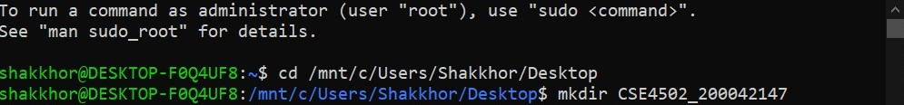

1. Task: Create a Sub Directory

Scenario: You want to organize all the files separately according to the respective lab. Create the directory “Lab02” in "CSE4502_yourid" directory.



1. Task: Copy Files Specific Directory

Scenario: You want to copy the lab handout and the assigned task to the specific lab directory.

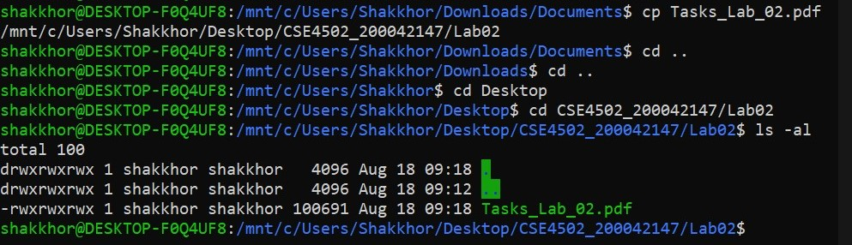

1. Task: Create and Append to a Text File

Scenario: You want to create a new text file named "notes.txt" in your "Lab02" folder. You also want to add some additional notes to the file without overwriting its content.

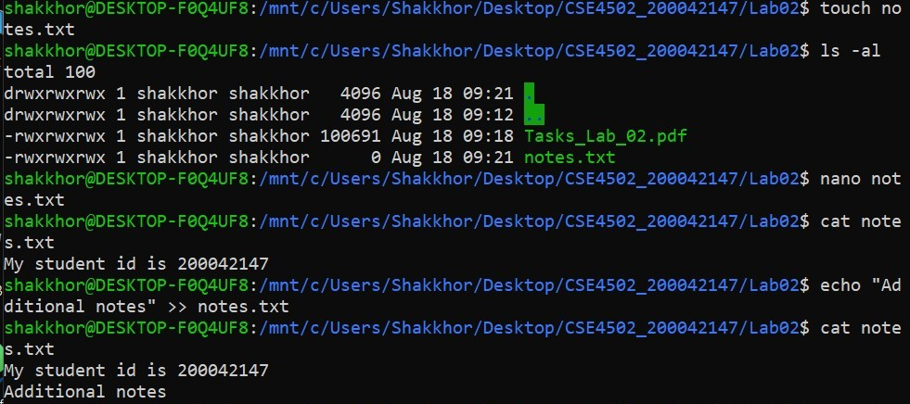

1. Task: Display Contents of Multiple Files

Scenario: You have two text files named "notes.txt" and "Tasks_Lab02.docx" in your "Lab02" folder. You want to display the contents of both files on the terminal.

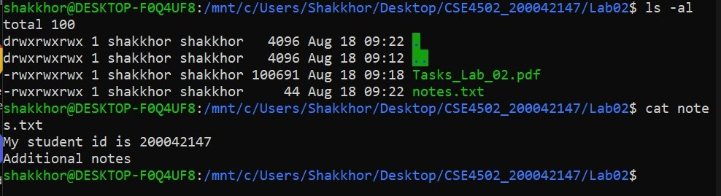

1. Task: List Files with Specific Extension

Scenario: You have a folder with various files. Display a list of all files with the ".txt" extension in that folder.

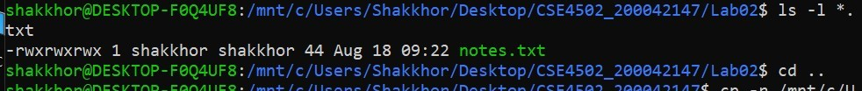

1. Task: Copy Files to a Backup Location

Scenario: You need to create a backup of your "CSE4502_yourid" folder to another folder mounted at "/media/user/Backup." Copy all contents of the "CSE4502_yourid" folder to this location.

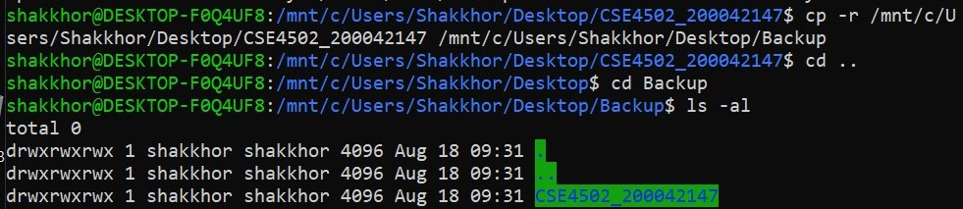

1. Task: Count the Number of Lines in a File

Scenario: You have a txt/pdf file. Determine the number of lines in this file

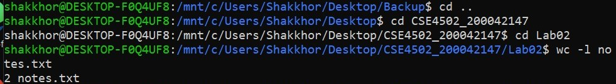

1. Task: Search for Text in Files

Scenario: Within your "CSE4502_yourid" folder, find all files that contain the text "linux"

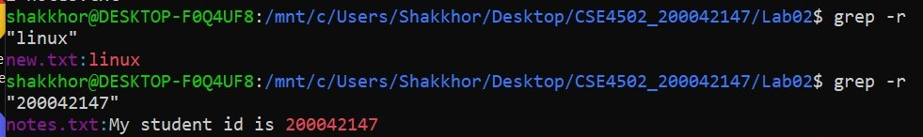

1. Task: Compress Files

Scenario: You need to create a compressed archive of the entire "Lab02" folder as "Lab02_yourid.tar.gz."

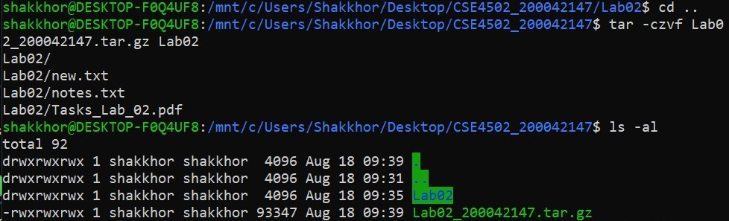

1. Task: Changing Permissions of a file

Scenario: You have a file named "notes.txt" in your "Lab02" folder. You want to grant read and write permission to root users but only read permissions to other groups.

